

Name : Adil Khan
Roll No : 2330-0030
Dept: BS AI
Subject: Data Base system

Lab no 01:

CREATE DATABASE TechVision;
USE TechVision;
CREATE TABLE employees (
emp_id INT PRIMARY KEY,
emp_name VARCHAR(50),
department VARCHAR(50),
job_title VARCHAR(50),
salary DECIMAL(10,2),
city VARCHAR(50),
hire_date DATE
);
INSERT INTO employees VALUES
(1, 'Ali Khan', 'HR', 'HR Manager', 75000, 'Islamabad', '2020-03-01'),
(2, 'Sara Ahmed', 'IT', 'Developer', 90000, 'Lahore', '2021-06-15'),
(3, 'Ahmed Raza', 'IT', 'Developer', 85000, 'Karachi', '2021-08-20'),
(4, 'Hina Malik', 'Finance', 'Accountant', 65000, 'Islamabad', '2020-01-05'),
(5, 'Bilal Arif', 'HR', 'Recruiter', 55000, 'Lahore', '2022-02-10'),
(6, 'Ayesha Noor', 'IT', 'Project Manager', 120000, 'Islamabad', '2019-07-19'),
(7, 'Farhan Ali', 'Finance', 'Accountant', 64000, 'Karachi', '2022-09-01'),
(8, 'Sana Tariq', 'IT', 'Developer', 88000, 'Lahore', '2023-03-25'),
(9, 'Usman Haq', 'Sales', 'Sales Executive', 60000, 'Karachi', '2021-04-10'),
(10, 'Zainab Iqbal', 'Sales', 'Sales Executive', 62000, 'Lahore', '2022-07-18');

Task no 1:

SELECT DISTINCT job_title
FROM employees;
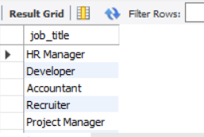
Task no 2:

SELECT emp_name
FROM employees
ORDER BY emp_name ASC;

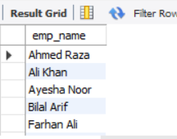
Task no 3:

SELECT department, salary
FROM employees
ORDER BY department ASC, salary DESC;

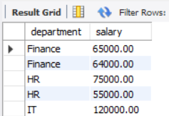
Task no 4:

SELECT DISTINCT department, city
FROM employees;

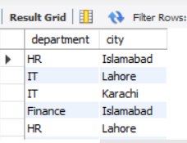
Task no 5:

SELECT job_title, COUNT(*) AS total_employees
FROM employees
GROUP BY job_title;

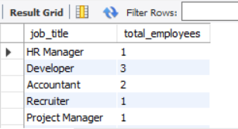
Task no 6:

SELECT city, COUNT(*) AS total_employees
FROM employees
GROUP BY city;

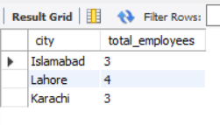
Task no 7:

SELECT emp_name, hire_date
FROM employees
ORDER BY hire_date ASC, emp_name DESC;

